**Housing Price Canada**

**Purpose of the study:**

The purpose of this study was to investigate the relationship among house prices and the different features of the house. The study is based on data collected of houses sold in city of Windsor, Canada, during July, August and September of 1987.

The dependent variable in this study was Price, and it is the sale price of a house. The independent variables were several features or aspects of the house. There are 546 observations, and these variables are: Lot size of a property in square feet(lotsize), Number of bedrooms(bedrooms), Number of full bathrooms (bathrooms), Number of stories excluding basement(stories), Number of garage places(garage).

The other independent binary variables we considered are: Does the house have a driveway? (driveway), Does the house have a recreational room? (recreation), Does the house have a full finished basement? (fullbase), Does the house use gas for hot water heating? (gasheat), Is there central air conditioning? (aircon), Is the house located in the preferred neighborhood of the city? (prefer).

Finally, we have two interaction variables within the independent variables, and they are: sq_height = lotsize*stories*fullbasement & sq_loc = lotsize* prefer

**Treatment of the data:**

The original data had no null values for any variables and descriptive statistics were examined for all variables. Additionally, we also created dummy variables for all of our independent variables except lotsize (See Appendix 1).

**Exploratory:**

First, as seen on Appendix 2, for our dependent variable or Price has a right skewed due to the long-right tail and is unimodal. From the histogram we see that most of the house prices are falling between 52500 and 82500. Moreover, it’s a rare event to get a price above 142500. We also see that the minimum price is about 22,500 and the maximum price is about 180,000.

Additionally, we also created a scatter plot to see the relationship between price and the independent variables. As shown in Appendix 3, the scatter plot shows a moderate positive correlation between lotsize and Price of the house. Moreover, based on Pearson Correlation Coefficients, we see there is a 0.54 correlation between lotsize and Price. Since correlations values are not appropriate for dummy variables, we decided to stop here in terms of exploratory analysis.

**Full Model Analysis:**

X = The Independent Variable

Y = Price

H0: β1 = 0; X has no relationship with Y

Ha: β1 ≠ 0; X have some relationship with Y

After splitting the data (80/20), we created our first full model using the training dataset. The full model has many variables with P-Value greater than 0.05 and indicated many predictors are not significant.

With a low 39.94 as F Value and many variable having p-value greater than(0.05) the data do not provide enough evidence that the x-variables have a significant effect on Y. We also cannot assume that X has some relationship with Y. Additionally, with Adj R-Sq being 0.6726, we can say about 67% of the variation in the Price can be explained using our full model. See Appendix 4 for more info.

As shown in Appendix 5, after looking at the residuals plots of the full model we check for the assumptions. Residual plots were only done on quantitative variables.

Linearity:From the residual plot we cannot tell if the data violated linearity. However, from the scatter plot we see a linear relationship between price and lotsize. Thus, linearity was not violated.

Constant variance:We see all of the data points randomly scattered around the zero line or mean of the residuals. Thus, constant variance was not violated.

Independence: We see the no clear pattern and the data is randomly spread around the plot. Thus, independence was not violated.

Normality:We do not see all of the points lie in a straight line. It is not considered a straight line due to the curve and break in the middle. Thus, normality was violated.

Since normality was violated for the full model, we transformed the dependent variable or Price variable.Price went from our initial right skewed distribution to an approximately normal distribution. By using log(Price) to transform our data the new dependent variable is ln_price(see appendix 3.5).

Shown in Appendix 6, the full model also suggests an issue with multicollinearity and suggests there is a relationship between the independent variables itself. We came to this conclusion given the VIF value was greater than 10 for many of the independent variables.

**Model Selection(Training):**

X = The Independent Variable

Y = Price

H0: β1 = 0; X has no relationship with Y

Ha: β1 ≠ 0; X have some relationship with Y

To address the issue with hypothesis testing, we are using different model selection methods. For this data set, we used Backward Elimination (BACKWARD), Stepwise (STEPWISE), Forward Selection (FORWARD), Mallow’s Cp (CP), and Adjusted R2 Selection (ADJRSQ). See Appendix 6 – 16 for more info, and Appendix 17 for the summary.

To establish the best performing model, we compared and analyzed R-Sq, Adj R-Sq, RMSE, MSE, and see if all predictors are significant. Furthermore, all of the models ended with parameters having P-value less than 0.05. With all of the models having a p-value being less than(0.05) and a sufficient F-value we can reject H0. Furthermore, we can also assume X has some relationship with Y within the final parameters of the models.

From this we can conclude that all of the models are almost identical. Even if there is a max and min, relatively speaking, there are extremely close and yield the same result in terms of model performance. It’s until we go to the third decimal place, where we can see little difference in performance.

Since there wasn’t enough variation with the models on the training dataset. We will try it on the test dataset to identify the best model on our test data. Trying our models on the test dataset will tell us how well the model works on unseen or predicting the outcome.

**Model Selection (Testing):**

From the testing data itself, we see all of the test result also giving us a similar result. That being said, all of the test result are fairly good for prediction. Our CV R-Sq threshold was < 0.3. So, for the test data set Forward method seems to give us a better predictive result.

From testing our model on the test dataset, we can see Forward method giving us a better result compared to the other models. Additionally, all of the other models tend to yield a similar result on the dataset. In terms of the error terms, both the RMSE and MAE are the on the lower end or smallest among the test models. This as a result, with the highest R-Sq, gave us the best model on our test dataset. See Appendix 18 for more info, and Appendix 19 for the summary.

For training there wasn’t sufficient variation to know the best model. However, for the test dataset see can see Forward method performing better compared to the other models. Thus, we will use Forward as our first model.

**Multicollinearity & Model Assumptions:**

As we finalize our model, we will analyze the issue of multicollinearity. We are using the VIF method where it tells you if the variance of a coefficient is inflated. As shows in Appendix 20, Test dataset model output *, num_bathroom_1* has a VIF value greater than 10. To fix this issue of multicollinearity we dropped the parameter from our first model. After rerunning the model, we see num_garage_0 also having a VIF value greater than 10, and we had to remove that variable too. After finishing the issue of multicollinearity, we checked the assumptions for the first model and moved a step towards the final model. Removing the two parameters also allows us to avoid a suggestion where the coefficients are poorly estimated, and we should take a second look at their p-values. It also ensures that none the coefficients switch signs due to the issue with multicollinearity.

As shown in Appendix 20, we can look at the residuals plots of the first model to check for the assumptions. For our first model:

Linearity: From the residual plot we cannot tell if the data violated linearity. However, from the scatter plot we see a linear relationship between price and lotsize. Thus, linearity was not violated.

Constant variance: We see all of the data points randomly scattered around the zero line or mean of the residuals. Thus, constant variance was not violated.

Independence: We see the no clear pattern and the data is randomly spread around the plot. Thus, independence was not violated.

Normality: We do see all of the points lie in a straight line. The line is relatively straight and shows normality after the data transformation. Thus, normality was not violated.

**Outliers:**

To check for outliers we looked for cases that are different from the majority and are not well explained by our model. We used Cook’s D distance and Studentized Residuals to find outliers in the model. As shown in Appendix 21, none of the data points in our first model had any outliers. There were no points where it was an both influential and an outlier data point. Thus, we did not remove or modify any data points and the R Sq remained the same.

**Final Model:**

After choosing FORWARD method, fixing the issue with multicollinearity, checking model assumptions, looking for outliers, we come to our final model. As for the final model, lotsize has the strongest influence on house Price due to the variable having the highest standardized estimate. Having a 3rd bathroom or num_bathroom_3 will have the highest effect on the house price. Having a 3rd bathroom will effect the price of the house by 41%. The second highest variable that will effect house price is having a four stories house excluding basement. Having a four stories high house will effect the price of the house by 29%. Finally, the third highest variable that will effect house price is having a central air conditioning system. Having Air conditioning system will affect the price of the house by 22%. See Appendix 22 for more info.

**Final Model Equation:**

log(new_y) = 10.44405 + 0.00004817 lotsize - 0.13062 num_bedroom_1 - 0.09304 num_bedroom_2 + 0.03337 num_bedroom_4 + 0.18090 num_bedroom_6 + 0.16051 num_bathroom_2 + 0.34539 num_bathroom_3 + 0.04249 num_stories_2 + 0.18671 num_stories_3 + 0.25487 num_stories_4 + 0.11914 num_driveway+ 0.06052 num_recreation + 0.10377 num_fullbase + 0.18214 num_gasheat+ 0.19581 num_aircon + 0.07810 num_garage_1 + 0.12086 num_garage_2 + 0.11243 num_prefer

Where,   
num_bedroom_1 = 1 = Yes;  
num_bedroom_2 = 1 = Yes;  
num_bedroom_4 = 1 = Yes;  
num_bedroom_6 = 1 = Yes;  
num_bathroom_2 = 1 = Yes;  
num_bathroom_3 = 1 = Yes;  
num_stories_2 = 1 = Yes;  
num_stories_3 = 1 = Yes;  
num_stories_4 = 1 = Yes;  
num_driveway = 1 = Yes;  
num_recreation = 1 = Yes;  
num_fullbase = 1 = Yes;  
num_gasheat = 1 = Yes;  
num_aircon = 1 = Yes;  
num_garage_1 = 1 = Yes;   
num_garage_2 = 1 = Yes;  
num_prefer = 1 = Yes;

**Prediction:**

Using our final model and all of the significant variables, we predicted two of the house prices as shown in Appendix 23 & Appendix 24.

As shown we seeour first dataset gave us a Y-value of 11.6157, 95% CL Mean of 11.2697-11.9617, and 95% CL Predict value of 11.0689-12.1625.

After retransformation we get a Y-Value(Price) = 110,823, 95% CL MEAN = (78,408 - 156,638), and 95% Cl Predict = (64,144 – 191,472)

Using the 1st dataset, we see our model predicted the price of the house be about 110,823 given all the significant conditions.

We are also 95% confident that the population parameter for the data point lies within 78,408 and 156,638.

We are also 95% confident that the Price will be found with our x-values within the interval range of 64,144 and 191,472.

As shown we seeour second dataset gave us a Y-value of 12.1002, 95% CL Mean of 11.7316-12.4687, and 95% CL Predict value of 11.5389-12.6615.

After retransformation we get a Y-Value(Price) = 110,823, 95% CL MEAN = (78,408 - 156,638), and 95% Cl Predict = (64,144 – 191,472)

Using the 2nd dataset, we see our model predicted the price of the house be about 179,907 given all the significant conditions.

We are also 95% confident that the population parameter for the data point lies within 124,442 and 260,067.

We are also 95% confident that the Price will be found with our x-values within the interval range of 102,630 and 315,368.

**Cross Validation:**

We analyzed how well our model predicts for new cases. We ran the 5-Fold cross-validation with 25% as test set and using different model selection methods as shown in Appendix 25-27.

When looking at the error terms we see both backwards and stepwise performing worse on the test datset. Furthermore ASE(Test) value is greater than ASE(Train), which suggests the model may not predict the random test sets very well. Additionally, while backward has the highest R-Sq, 0it performs the worst compared to the other model selection methods. Stepwise also has a similar R-Sq to backward, but Stepwise also does not perform too well on the random test sets. Finally, using the forward method, it not only performs better than the training dataset, but it also has the lowest error on the random test dataset.

This confirms that Forward performs the best on new unseen(test) dataset compared to backwards and stepwise. Thus, it also readdresses our final model being forward compared to any other selection methods.

**Conclusion/Improvement:**

While the model did improve in terms of R-Sq, a few adjustments can be made to make the model predict even better. First, we can obtain more data and have a larger sample size. Alternatively, we can collect data for the whole year and adjust for seasonality. There could be a seasonal or historical component associated with 1987 in the months of July, August and September.

**Appendix**

**Appendix 1: Data**

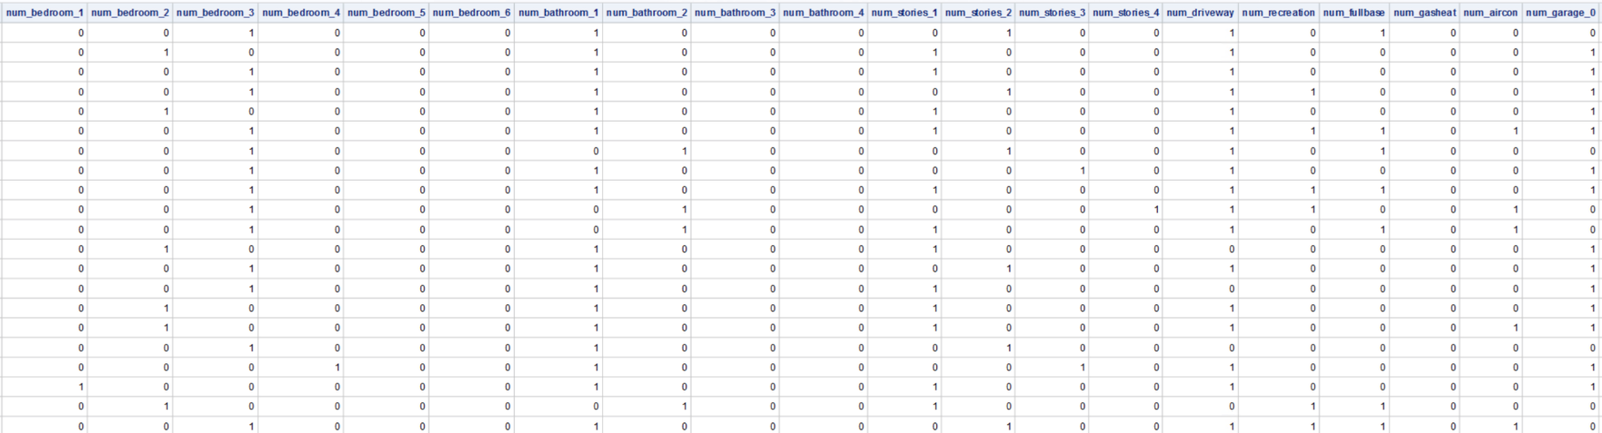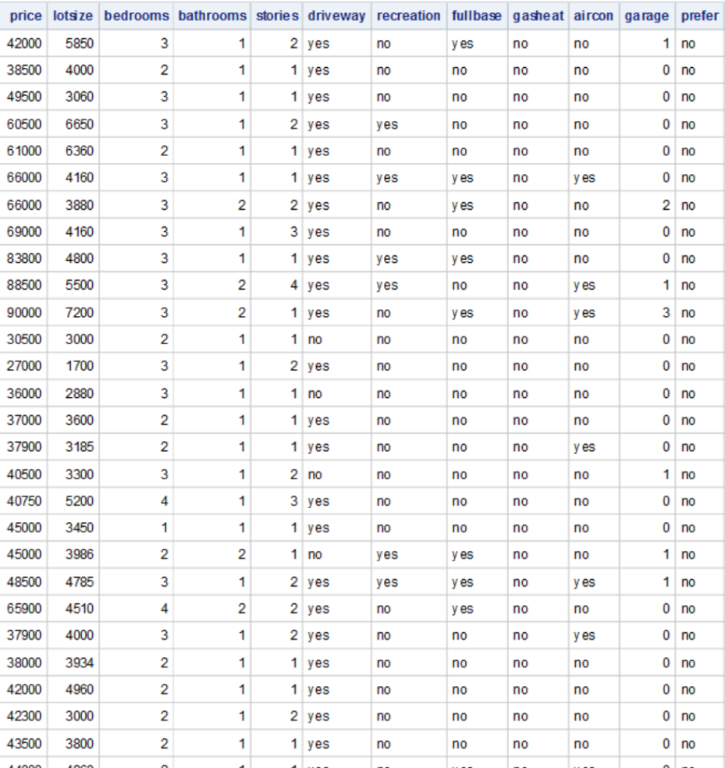

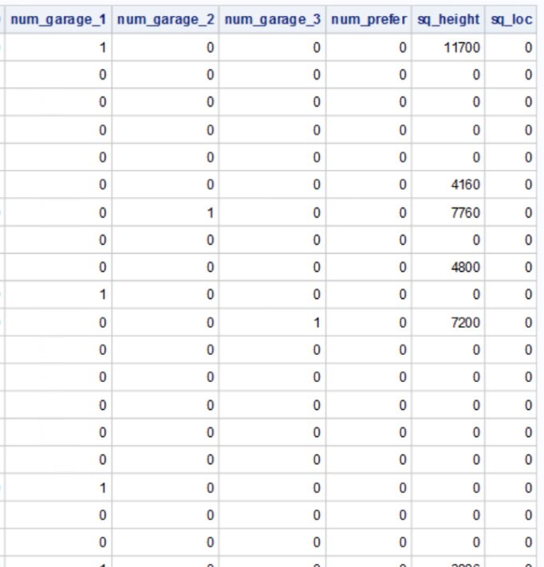

**Appendix 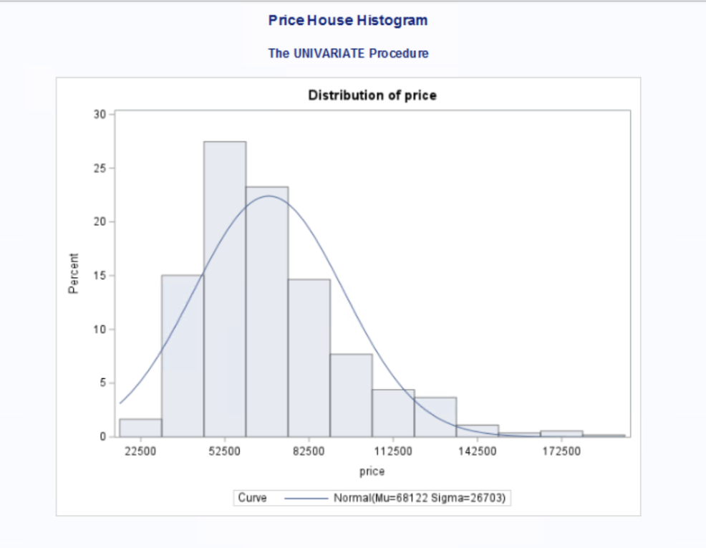2: Histogram of Price**

**Appendix 3: Scatter plot & Pearson Correlation Coefficients**

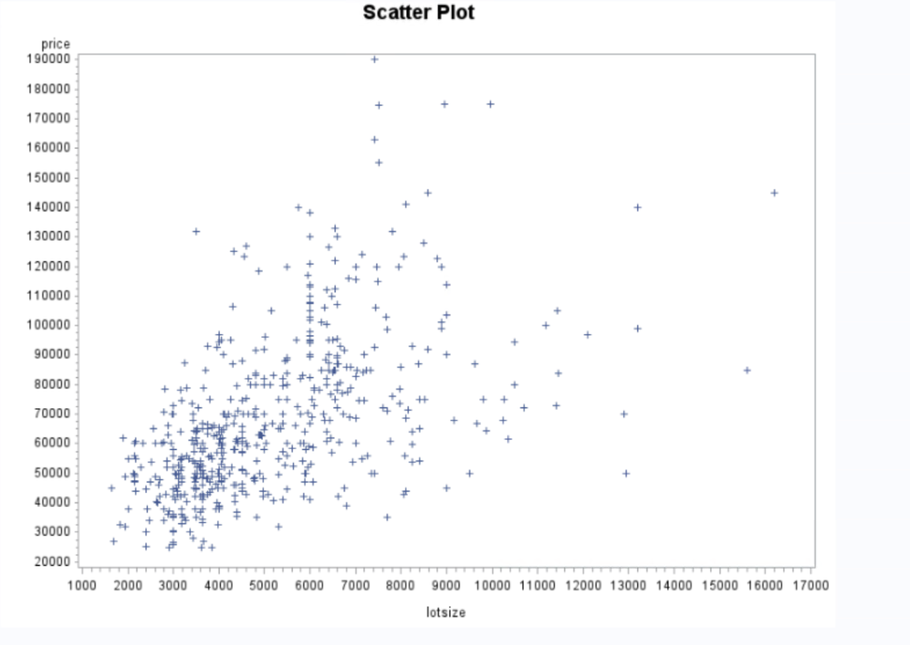

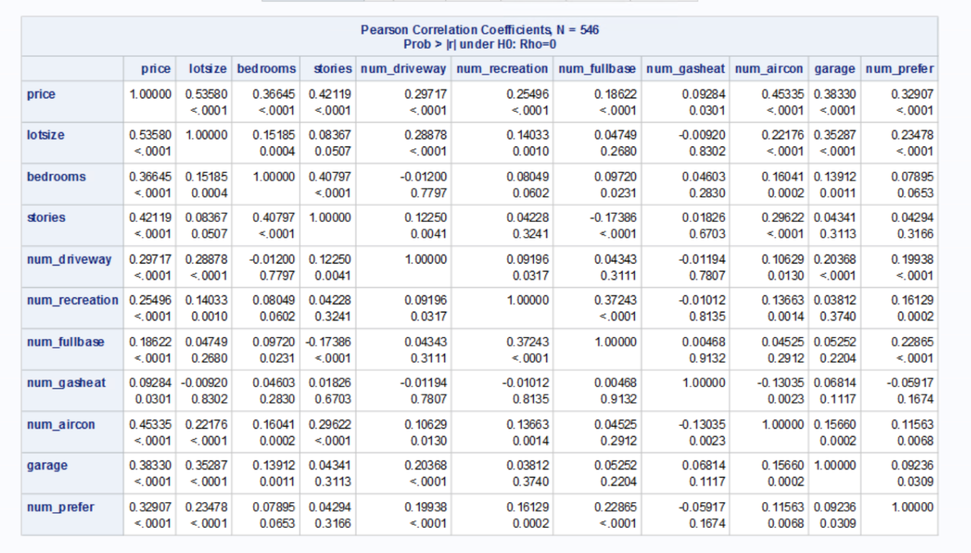

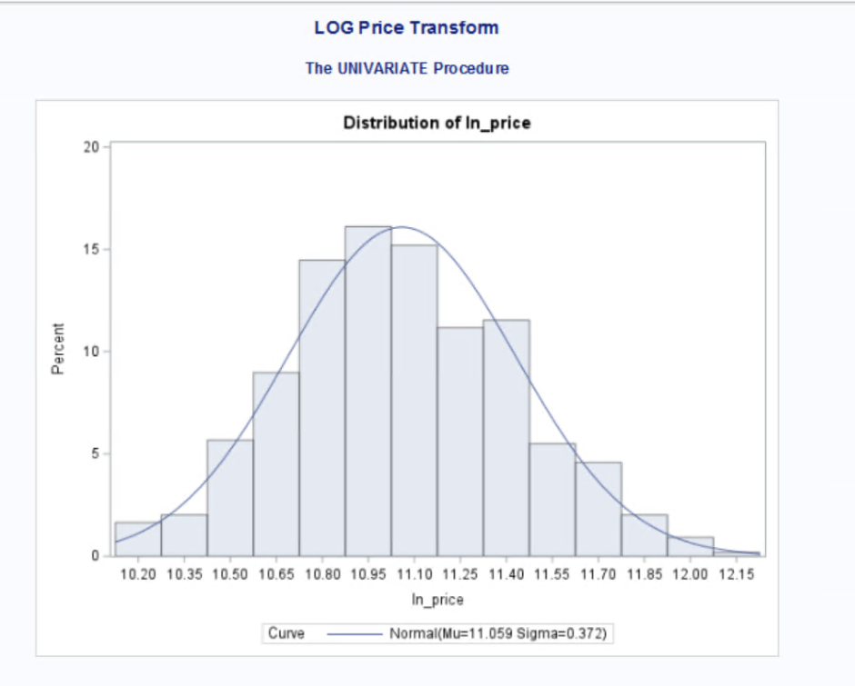**Appendix 3.5: log(Price) Transformation Histogram**

**Appendix 4: Full model output**

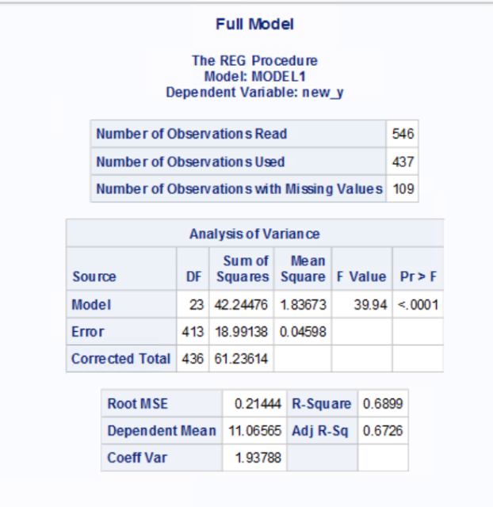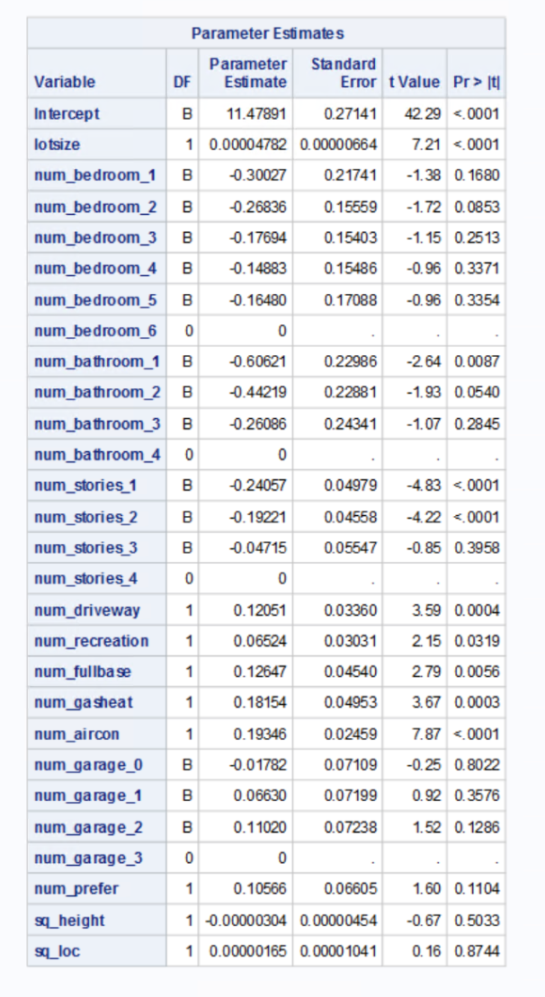

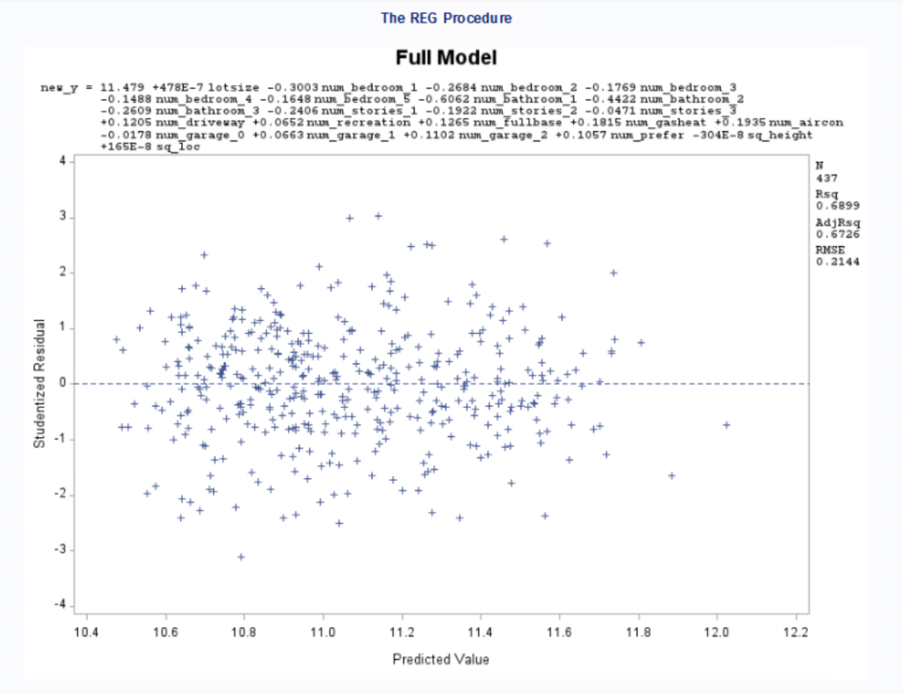**Appendix 5: 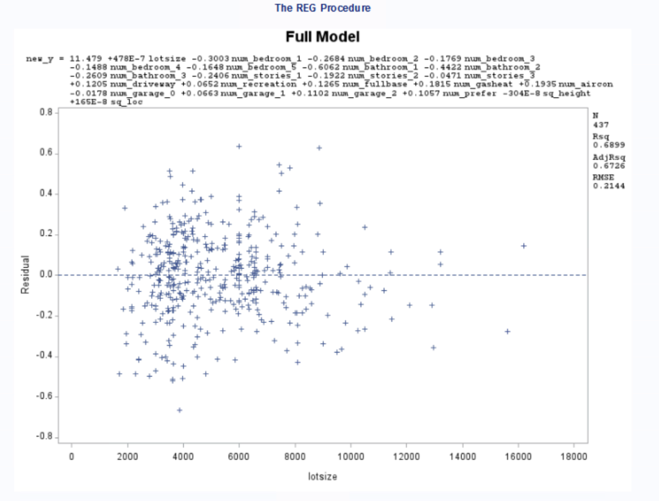Full model residual plots**

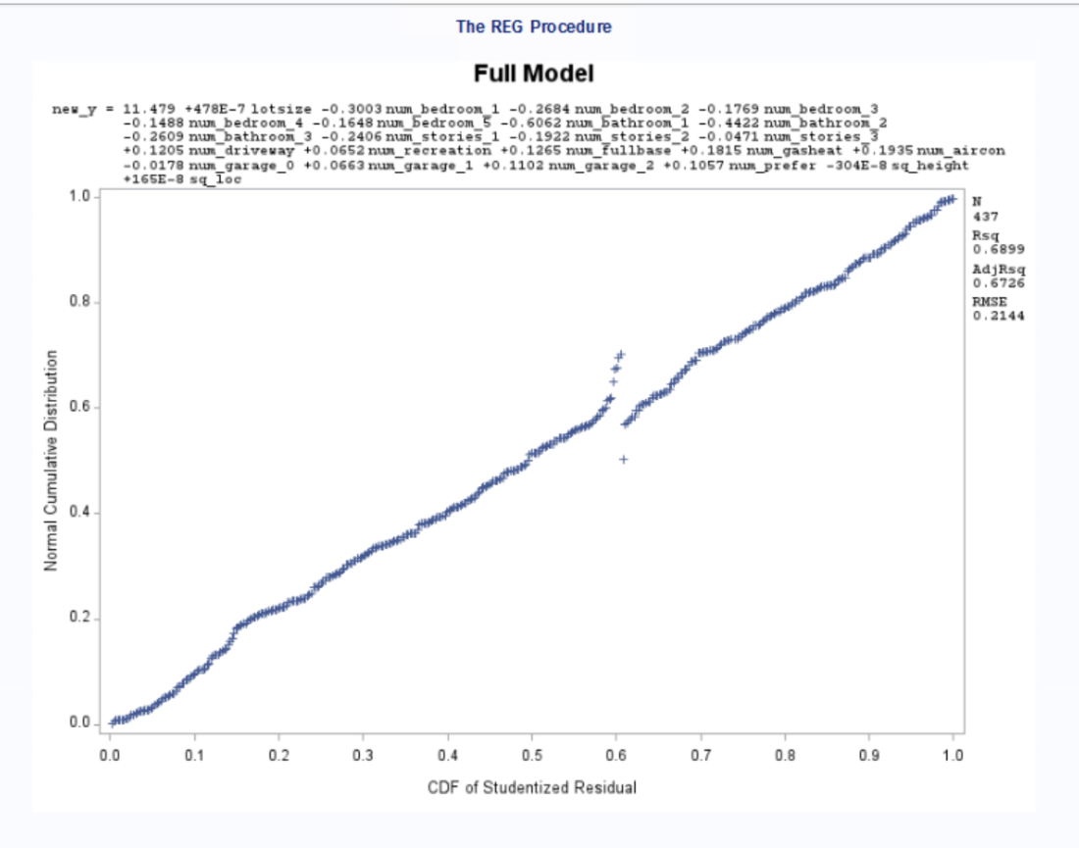

**Appendix 6: Full model multicollinearity**

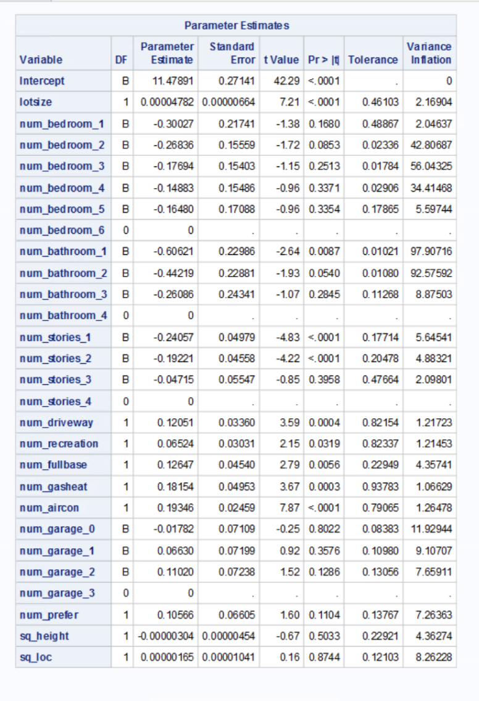

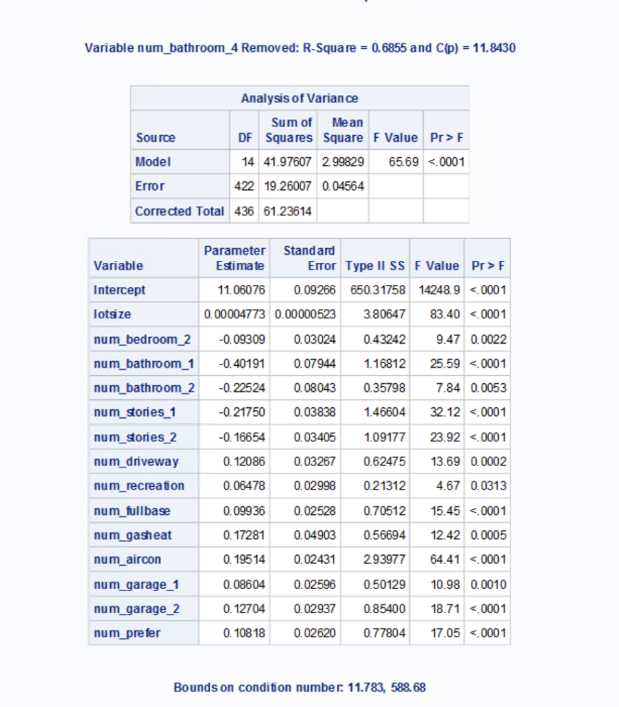**Appendix 7: BACKWARD Model output**

**Appendix 8: Stepwise model output**

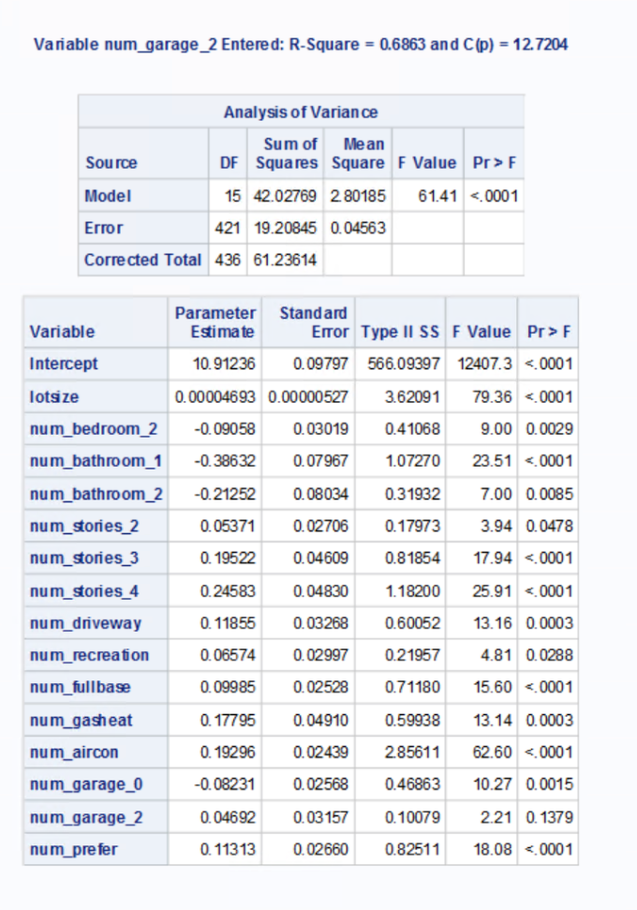

**Appendix 9: Forward model output**

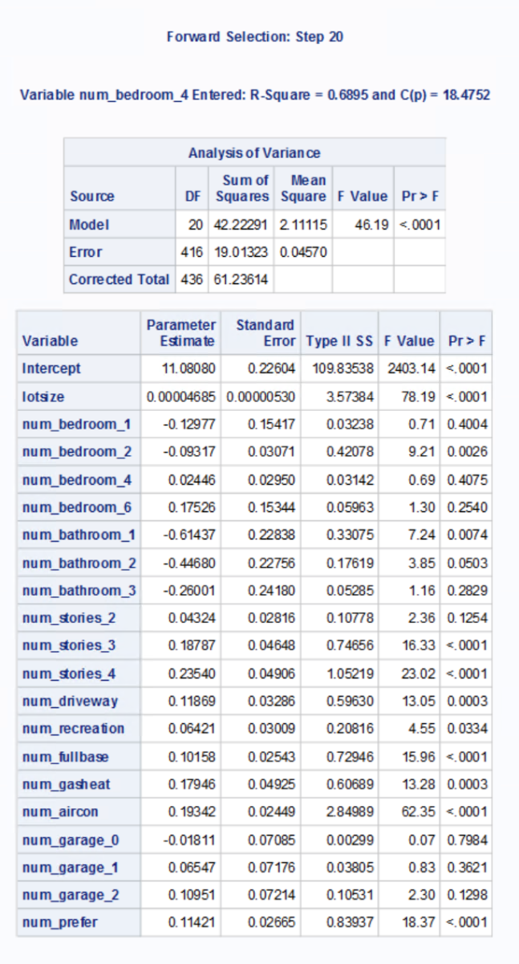

**Appendix 10: CP model output**



**Appendix 11: ADJRSQ model output**



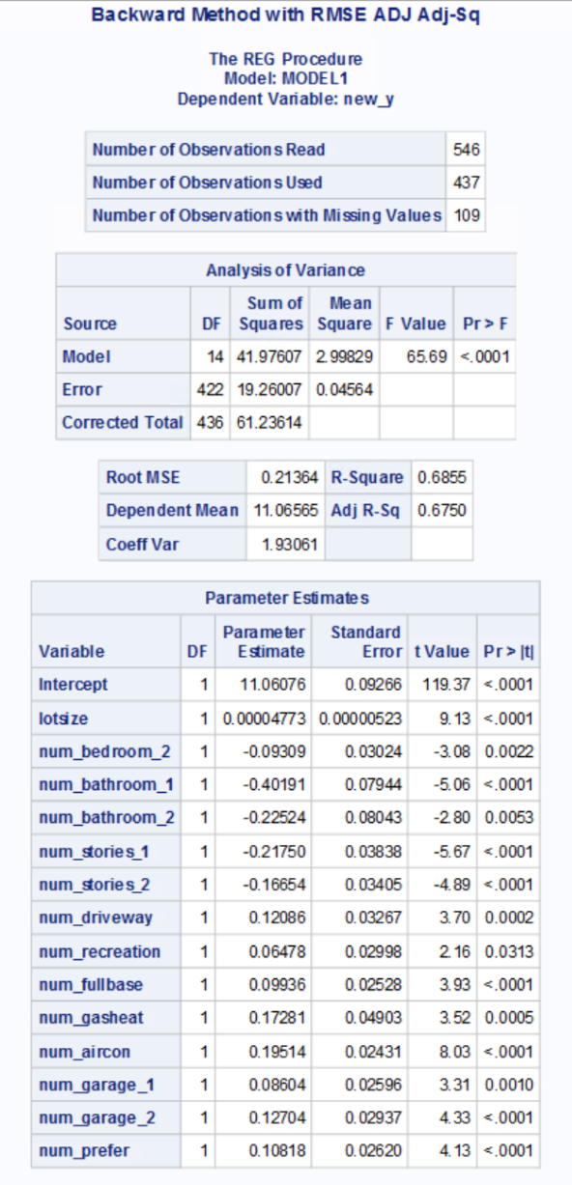 **Appendix 12: Backward with errors**

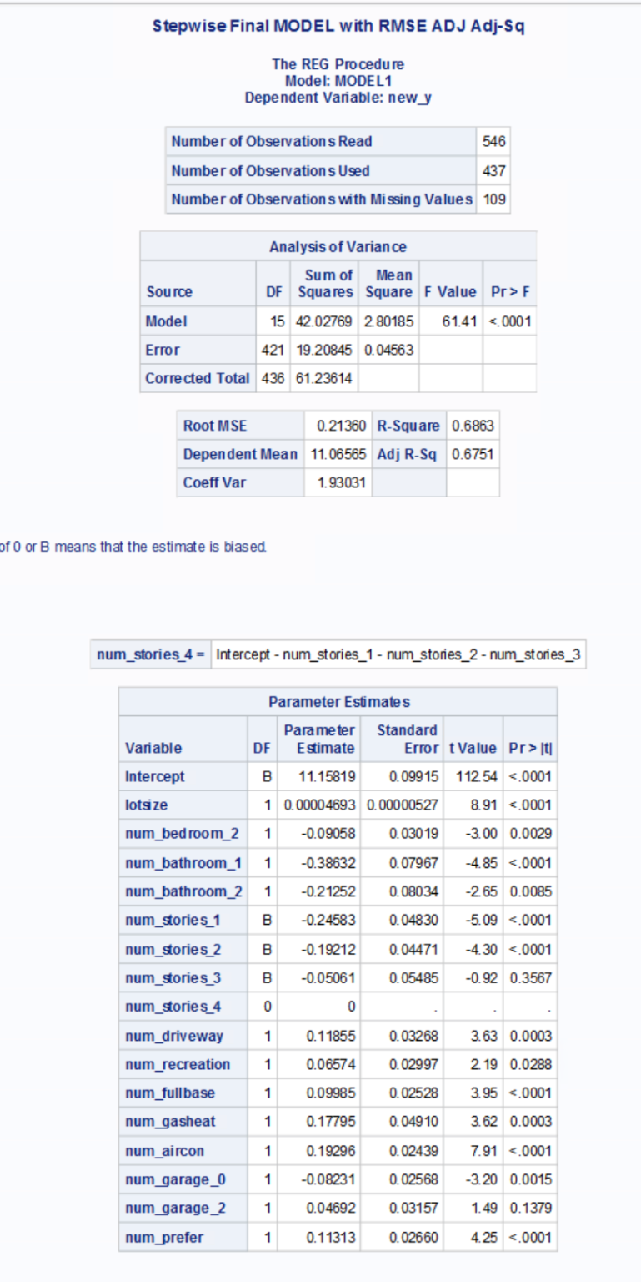**Appendix 13: Stepwise with errors**

**Appendix 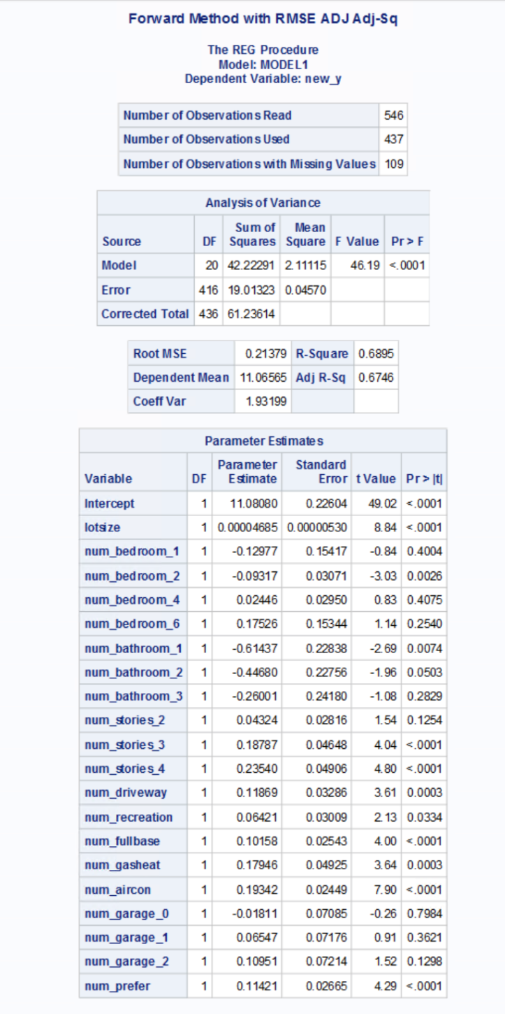14: Forward with errors**

**Appendix 15: CP with errors**

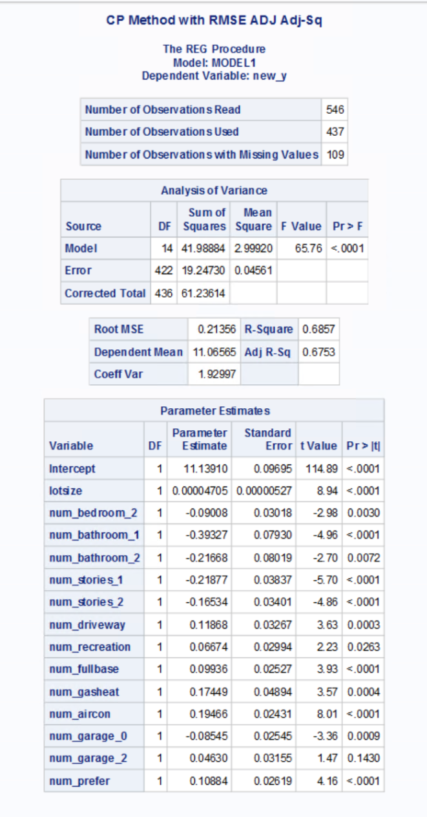

**Appendix 16: ADJRSQ with errors**

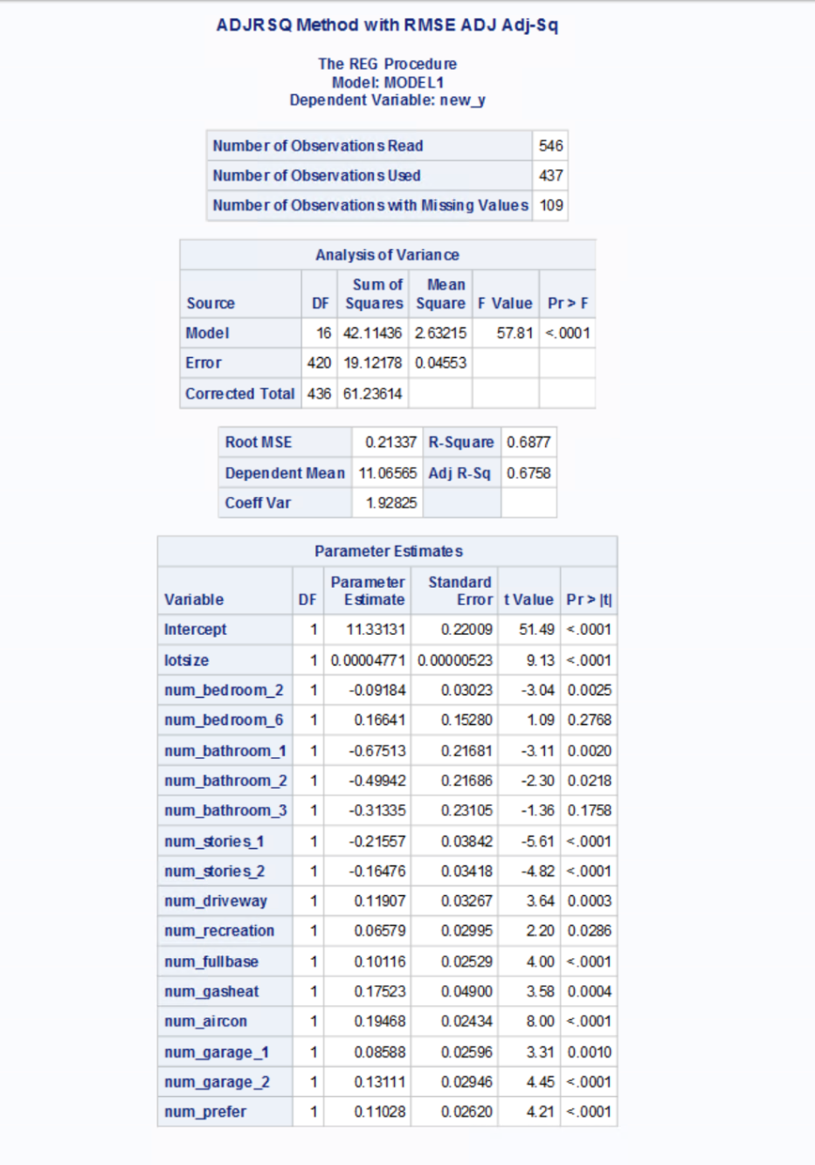

**Appendix 17: Summary of Training dataset model output**

|  |  |  |  |  |  |
| --- | --- | --- | --- | --- | --- |
| **Model Performance Training 80/20** | | | | | |
|  | **Backward** | **Stepwise** | **Forward** | **CP** | **ADJRSQ** |
| **R-Sq** | 0.6855 | 0.6863 | 0.6895 | 0.6857 | 0.6877 |
| **Adj R-Sq** | 0.6750 | 0.6751 | 0.6746 | 0.6753 | 0.6758 |
| **RMSE** | 0.21364 | 0.2136 | 0.21379 | 0.21356 | 0.21337 |
| **MSE** | 0.04564 | 0.04563 | 0.0457 | 0.04561 | 0.04553 |
| **P<0.05** | Yes | Yes | Yes | Yes | Yes |

**Appendix 18: Test dataset model output**

Backward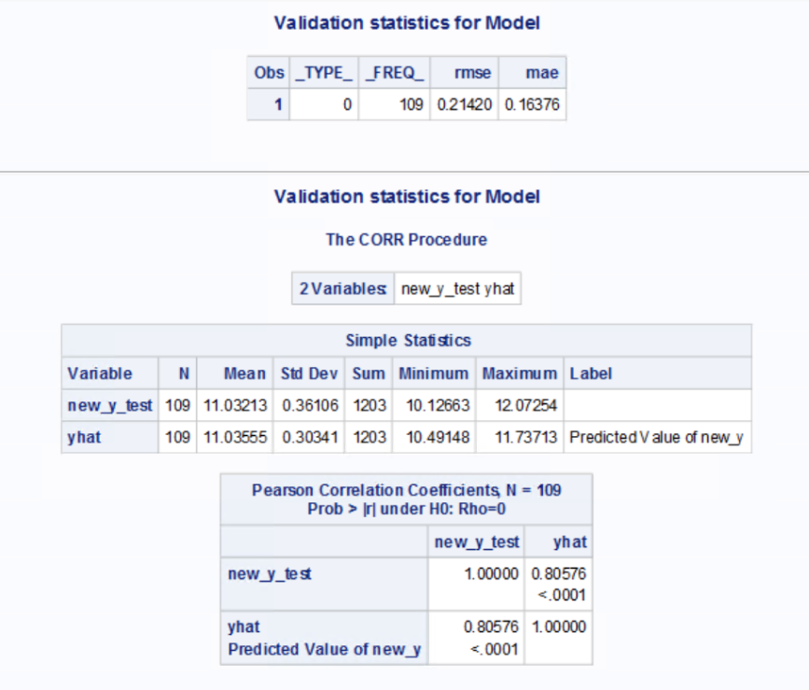 Forward

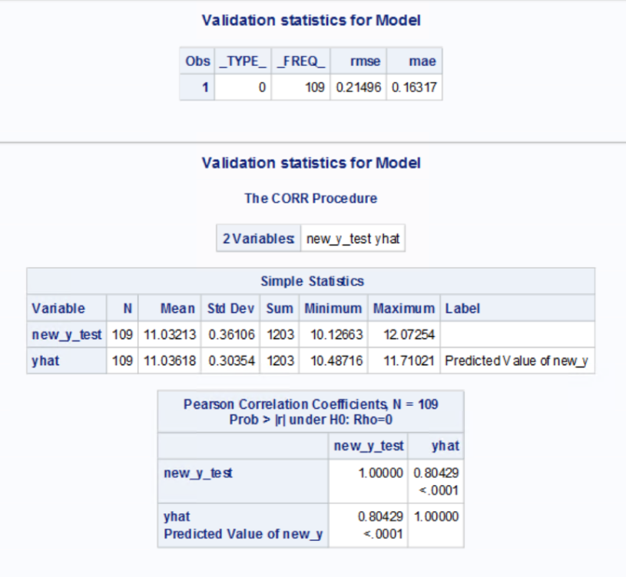

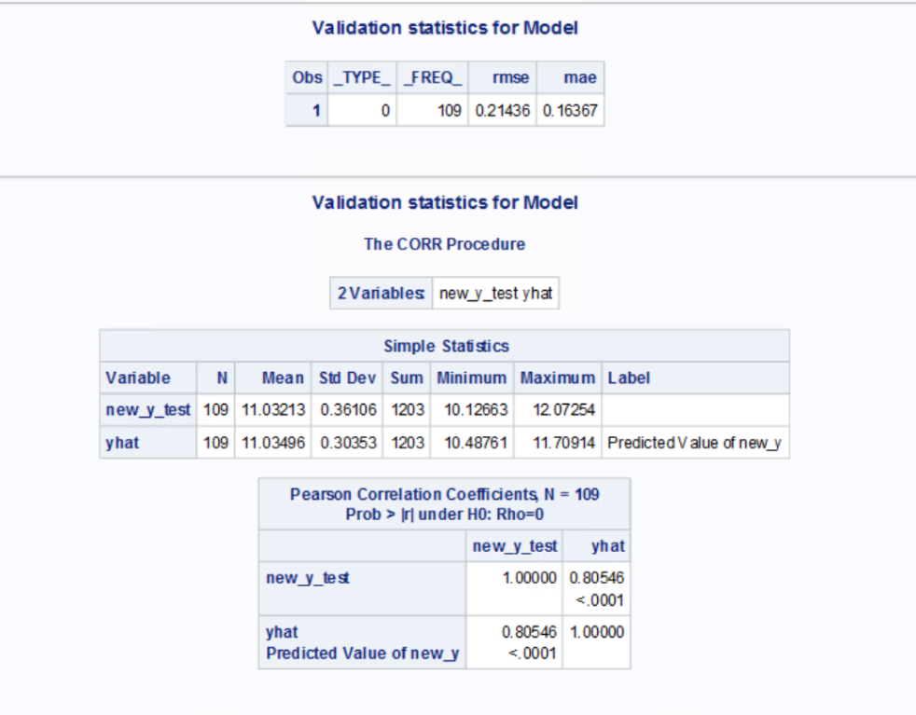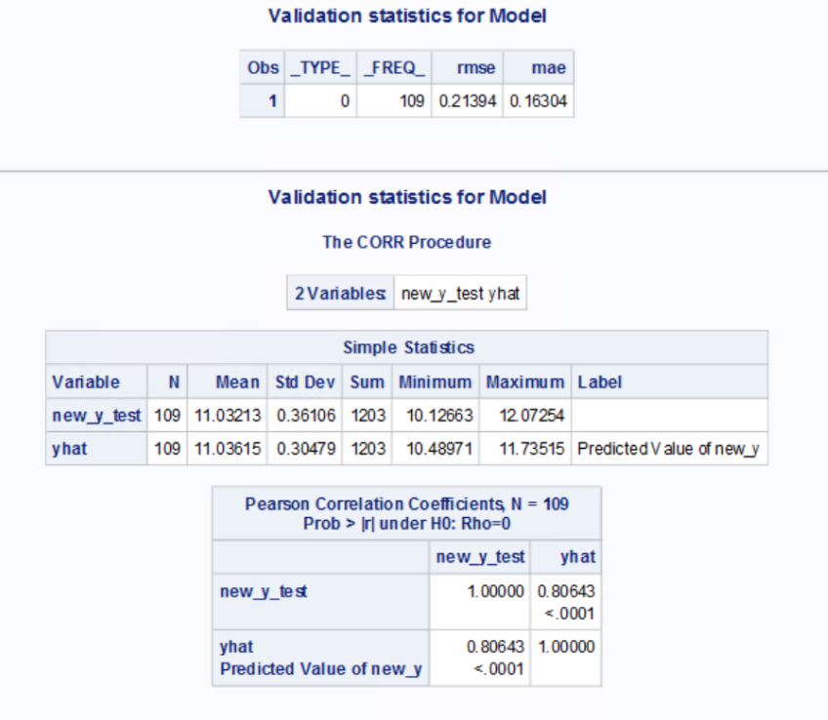 Stepwise ADJRSQ

CP

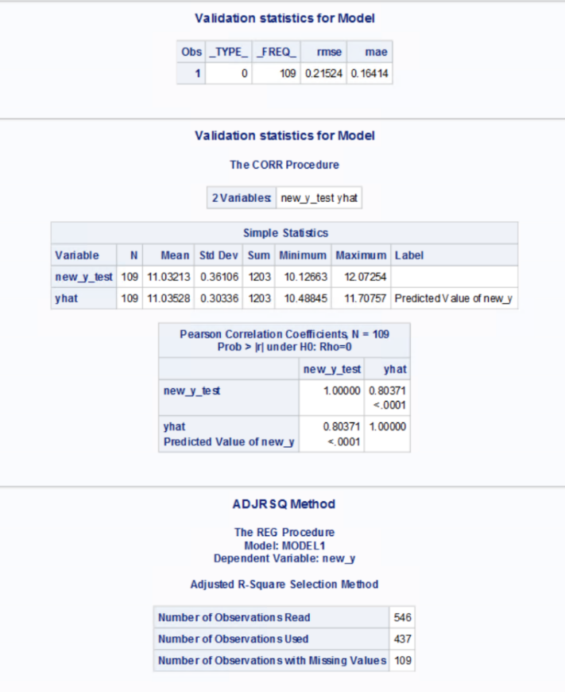

**Appendix 19: Test dataset model output**

|  |  |  |  |  |  |
| --- | --- | --- | --- | --- | --- |
|  | **Model Performance Testing 20/80** | | | | |
|  | **Backward** | **Stepwise** | **Forward** | **CP** | **ADJRSQ** |
| **R-Sq** | 0.80429 | 0.80643 | 0.80576 | 0.80371 | 0.80546 |
| **RMSE** | 0.21496 | 0.21394 | 0.2142 | 0.2152 | 0.2144 |
| **MAE** | 0.16317 | 0.16304 | 0.1638 | 0.1641 | 0.1637 |
| **CV R-Sq** | 0.038618 | 0.035971 | 0.040251 | 0.03975 | 0.038934 |

**Appendix 20: Final Model Multicollinearity & Final Model Residuals**

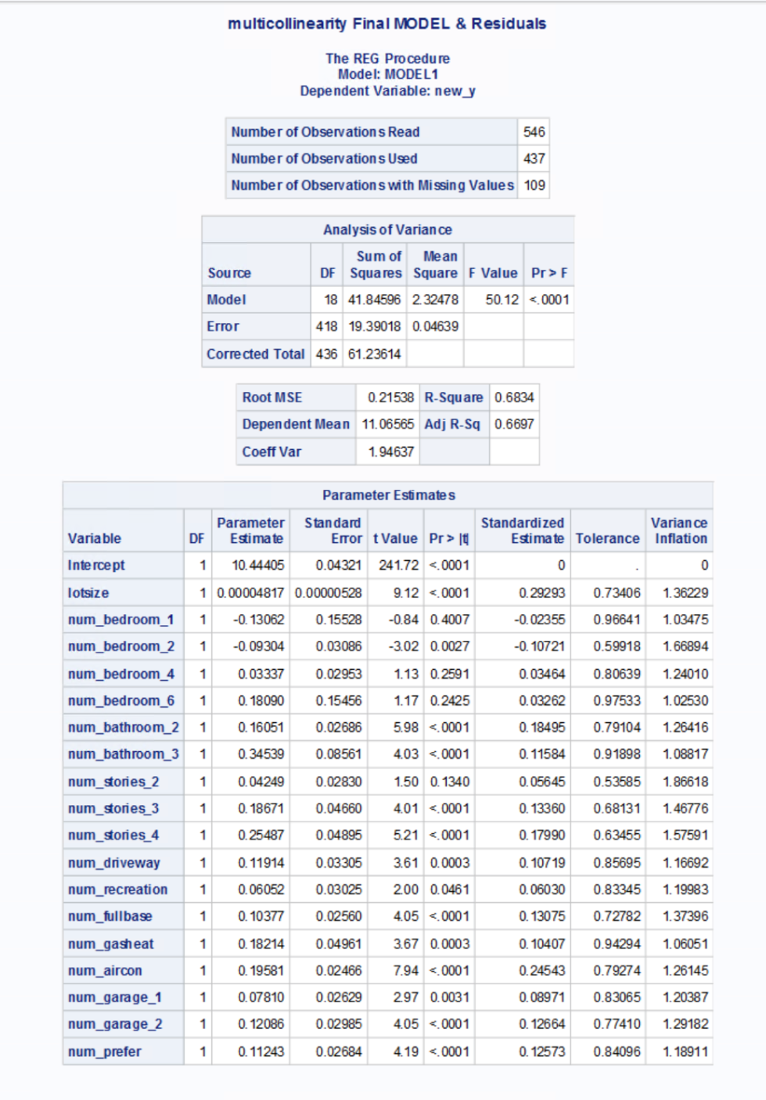

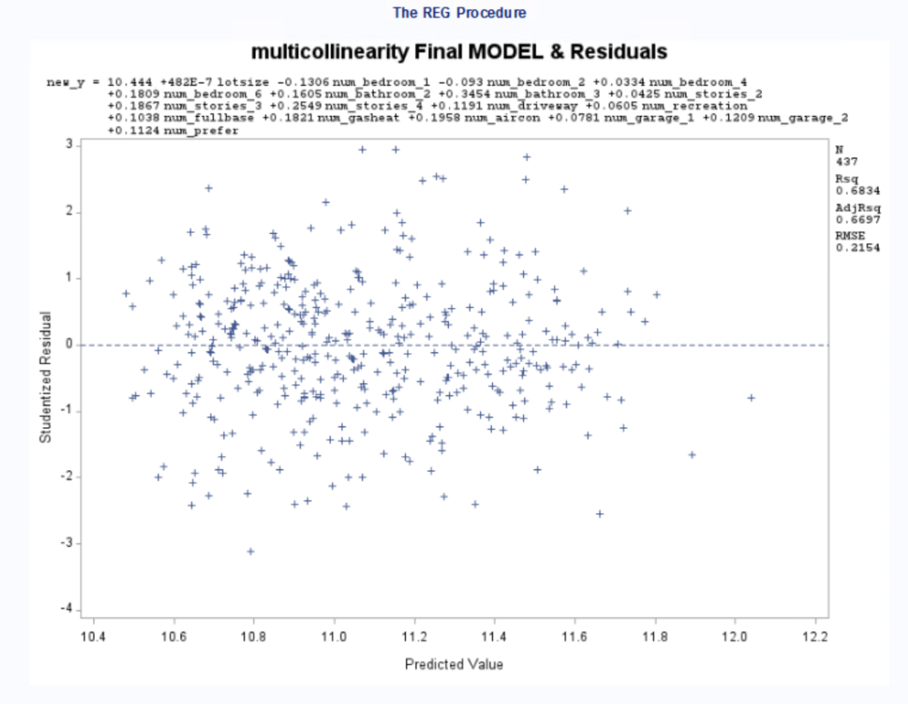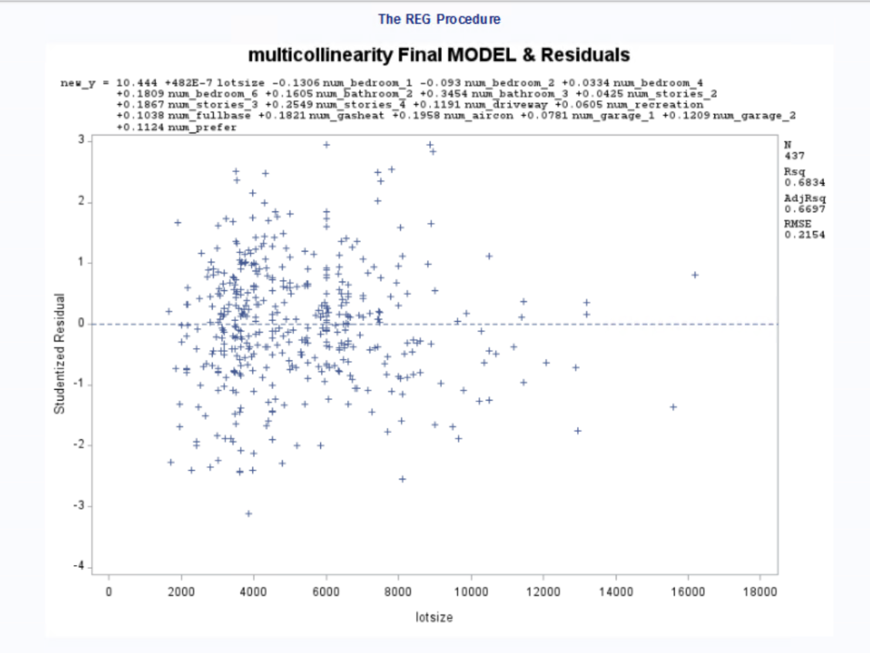

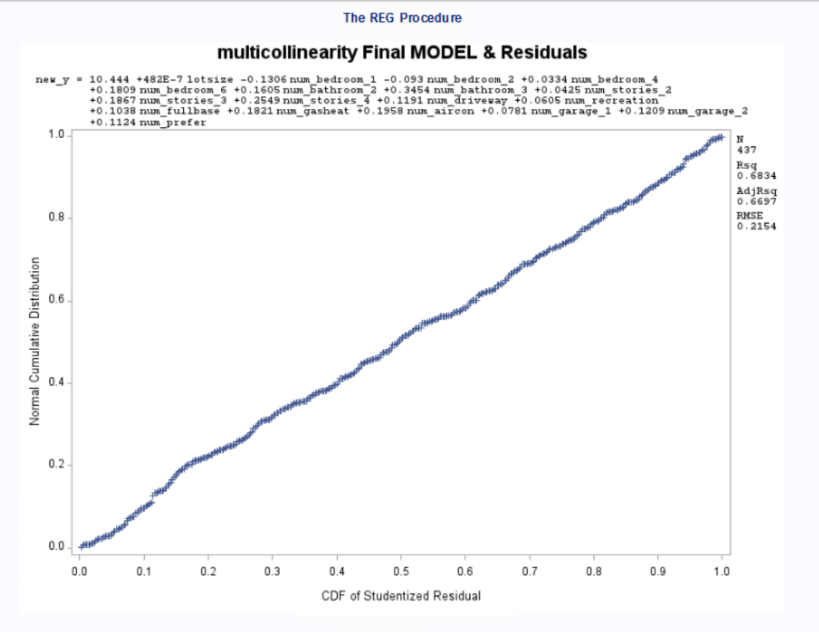

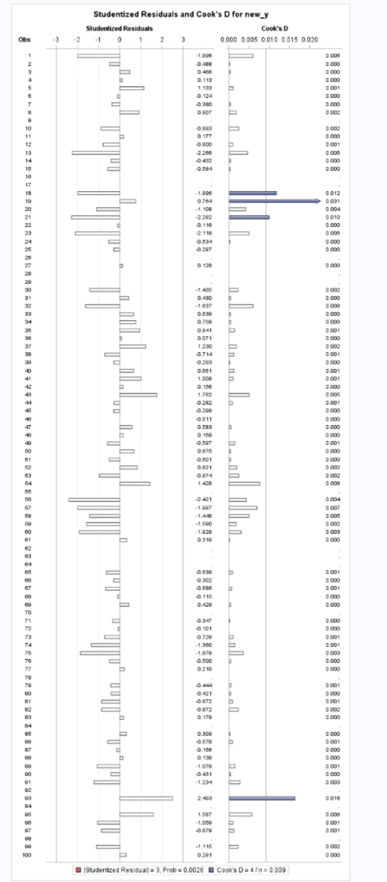**Appendix 21: Outliers**

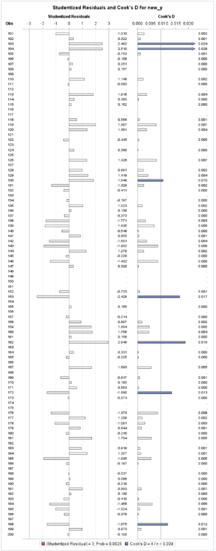

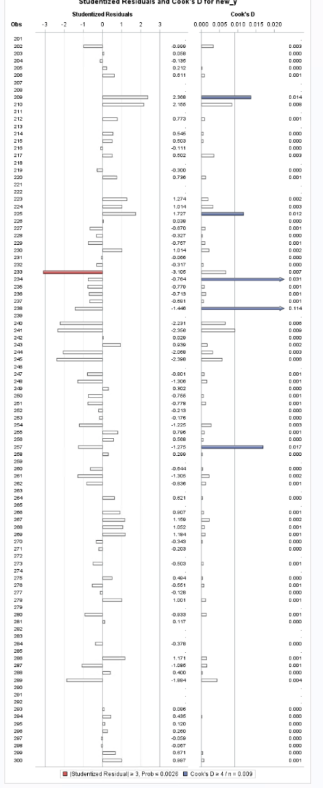

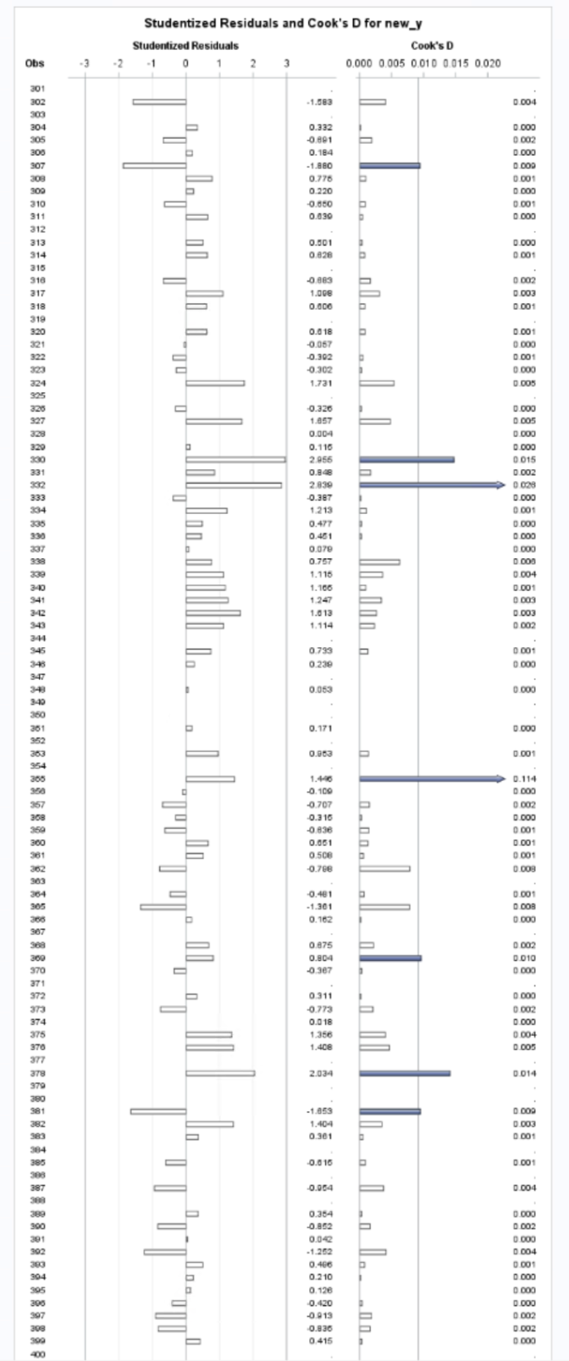

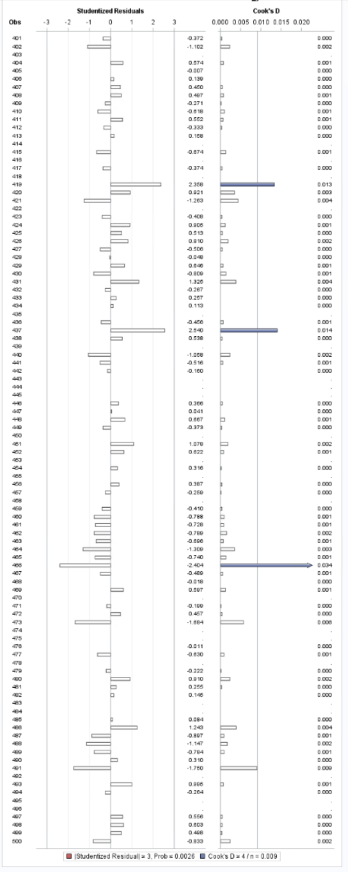

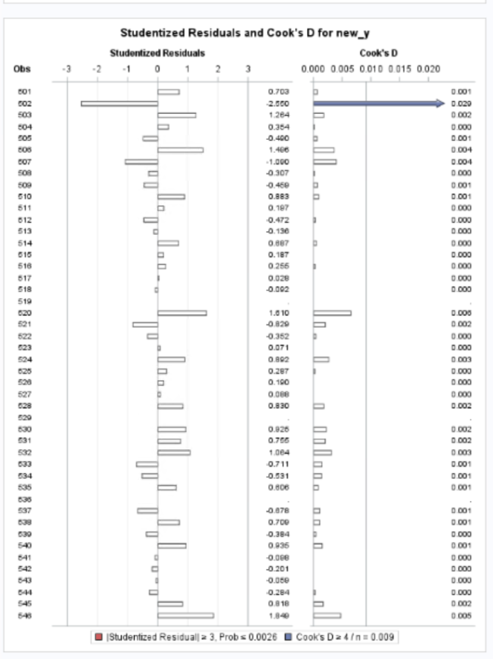

**Appendix 22: Final Model Output**

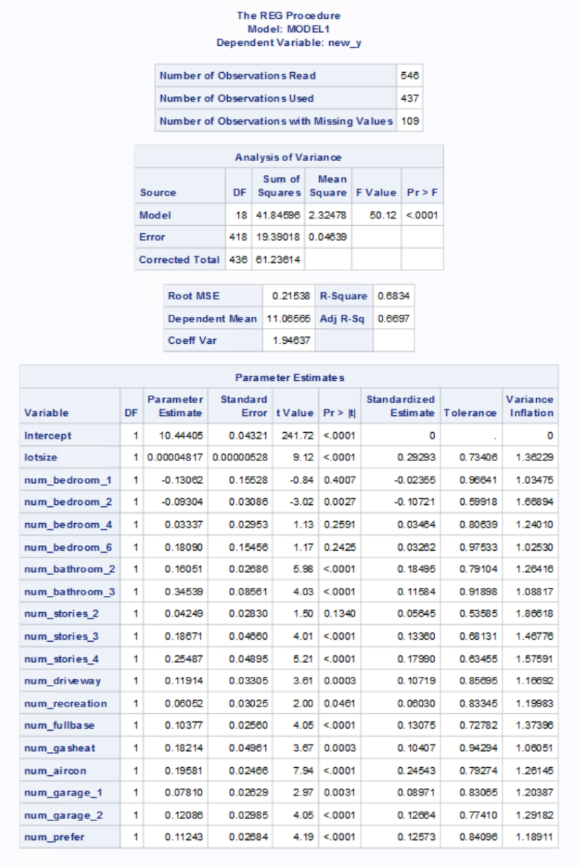

|  |  |  |
| --- | --- | --- |
| **Parameters** | **Coefficients** | **Effect -> Price** |
| Lotsize | 0.00004817 | 0% |
| num_bedroom_1 | -0.13062 | -12% |
| num_bedroom_2 | -0.09304 | -9% |
| num_bedroom_4 | 0.03337 | 3% |
| num_bedroom_6 | 0.1809 | 20% |
| num_bathroom_2 | 0.16051 | 17% |
| num_bathroom_3 | 0.34539 | 41% |
| num_stories_2 | 0.04249 | 4% |
| num_stories_3 | 0.18671 | 21% |
| num_stories_4 | 0.25487 | 29% |
| num_driveway | 0.11914 | 13% |
| num_recreation | 0.06052 | 6% |
| num_fullbase | 0.10377 | 11% |
| num_gasheat | 0.18214 | 20% |
| num_aircon | 0.19581 | 22% |
| num_garage_1 | 0.0781 | 8% |
| num_garage_2 | 0.12086 | 13% |
| num_prefer | 0.11243 | 12% |

log(new_y) = 10.44405 + 0.00004817 lotsize - 0.13062 num_bedroom_1 - 0.09304 num_bedroom_2 + 0.03337 num_bedroom_4 + 0.18090 num_bedroom_6 + 0.16051 num_bathroom_2 + 0.34539 num_bathroom_3 + 0.04249 num_stories_2 + 0.18671 num_stories_3 + 0.25487 num_stories_4 + 0.11914 num_driveway+ 0.06052 num_recreation + 0.10377 num_fullbase + 0.18214 num_gasheat+ 0.19581 num_aircon + 0.07810 num_garage_1 + 0.12086 num_garage_2 + 0.11243 num_prefer

Where,   
num_bedroom_1 = 1 = Yes;  
num_bedroom_2 = 1 = Yes;  
num_bedroom_4 = 1 = Yes;  
num_bedroom_6 = 1 = Yes;  
num_bathroom_2 = 1 = Yes;  
num_bathroom_3 = 1 = Yes;  
num_stories_2 = 1 = Yes;  
num_stories_3 = 1 = Yes;  
num_stories_4 = 1 = Yes;  
num_driveway = 1 = Yes;  
num_recreation = 1 = Yes;  
num_fullbase = 1 = Yes;  
num_gasheat = 1 = Yes;  
num_aircon = 1 = Yes;  
num_garage_1 = 1 = Yes;   
num_garage_2 = 1 = Yes;  
num_prefer = 1 = Yes;

**Appendix 23: Prediction**

|  |  |
| --- | --- |
| **1st data** | **2nd data** |
| lotsize = 3200 | lotsize = 4000 |
| num_bedroom_1 = Yes | num_bedroom_1 = No |
| num_bedroom_2 = No | num_bedroom_2 = No |
| num_bedroom_4 = No | num_bedroom_4 = No |
| num_bedroom_6 = No | num_bedroom_6 = Yes |
| num_bathroom_2 = Yes | num_bathroom_2 = No |
| num_bathroom_3 = No | num_bathroom_3 = Yes |
| num_stories_2 = No | num_stories_2 = Yes |
| num_stories_3 = NO | num_stories_3 = No |
| num_stories_4 = Yes | num_stories_4 = No |
| num_driveway = Yes | num_driveway = Yes |
| num_recreation = Yes | num_recreation = Yes |
| num_fullbase = Yes | num_fullbase = Yes |
| num_gasheat = Yes | num_gasheat = Yes |
| num_aircon = Yes | num_aircon = Yes |
| num_garage_1 = Yes | num_garage_1 = No |
| num_garage_2 = No | num_garage_2 = Yes |
| num_prefer = Yes | num_prefer = Yes |

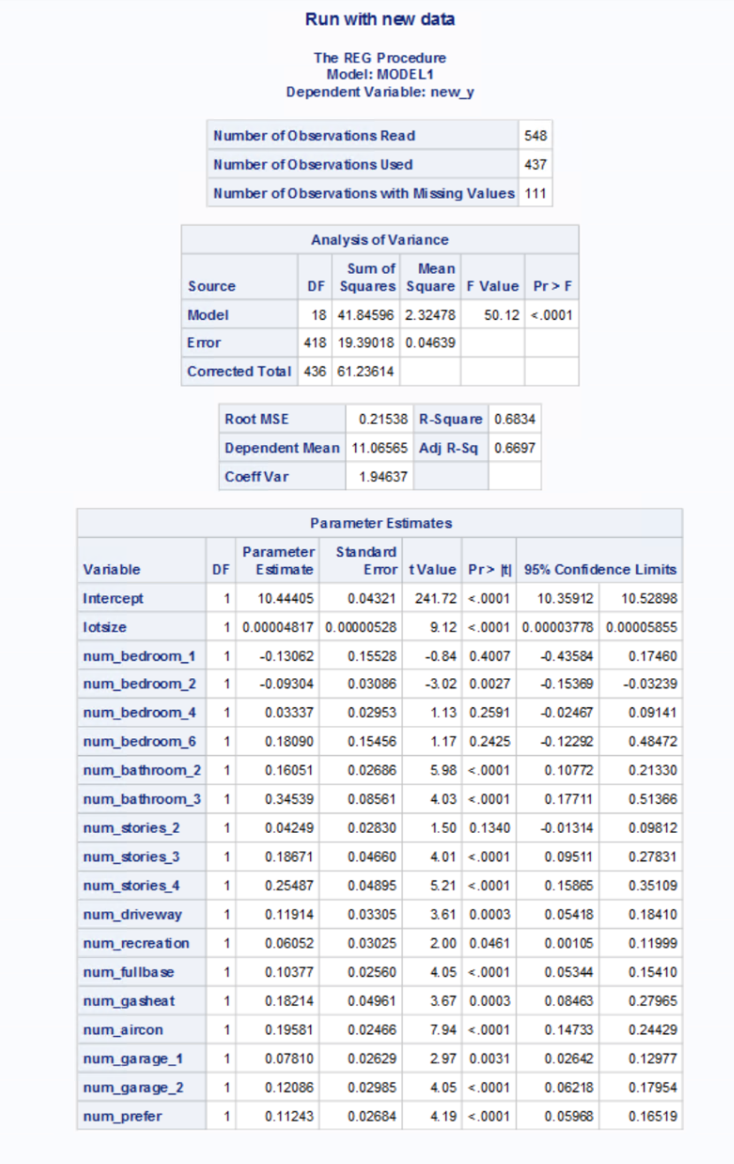

**Appendix 24: Prediction Interval**

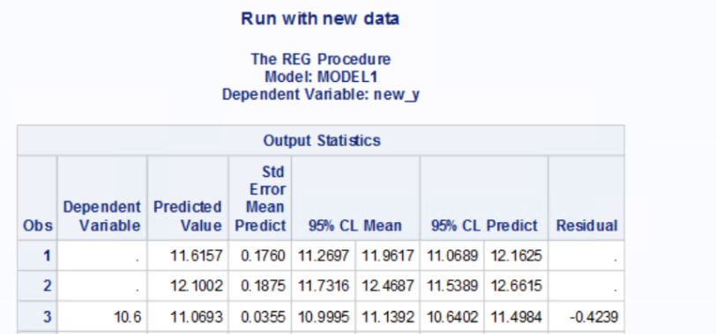

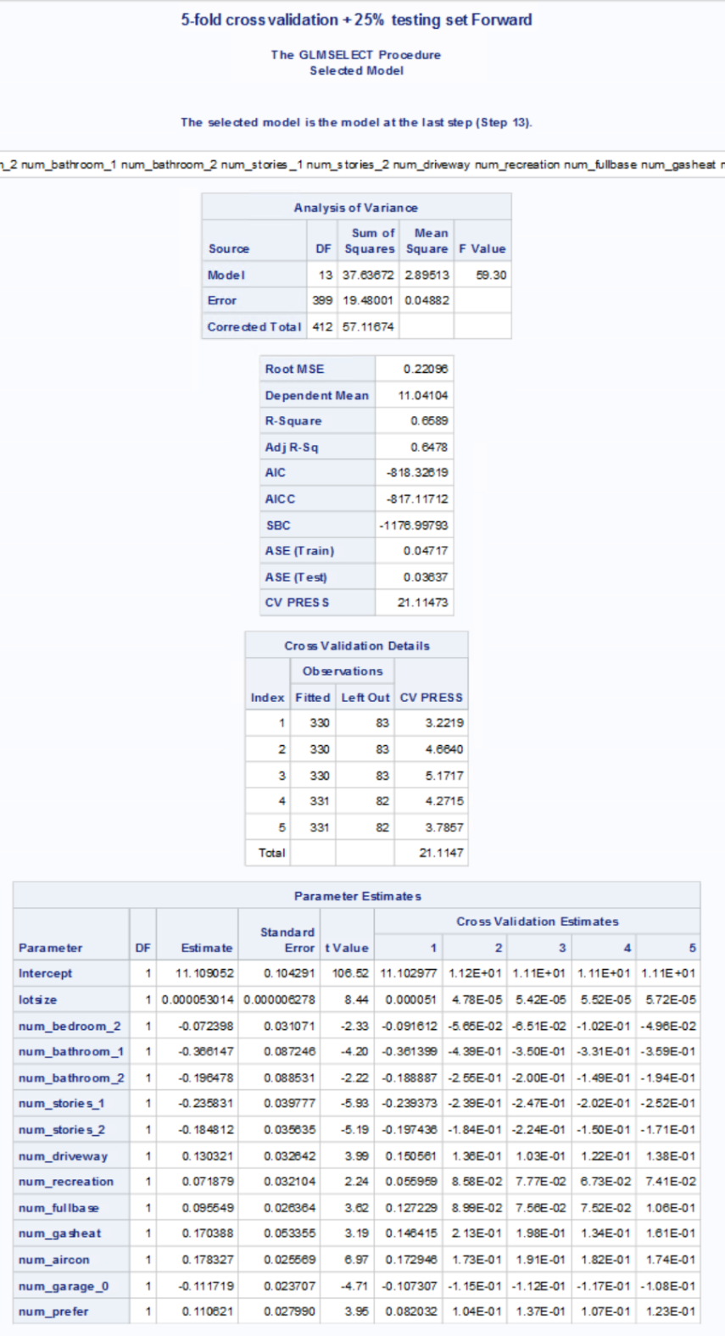**Appendix 25: 5- Fold Cross Validation + 25% testing using Forward**

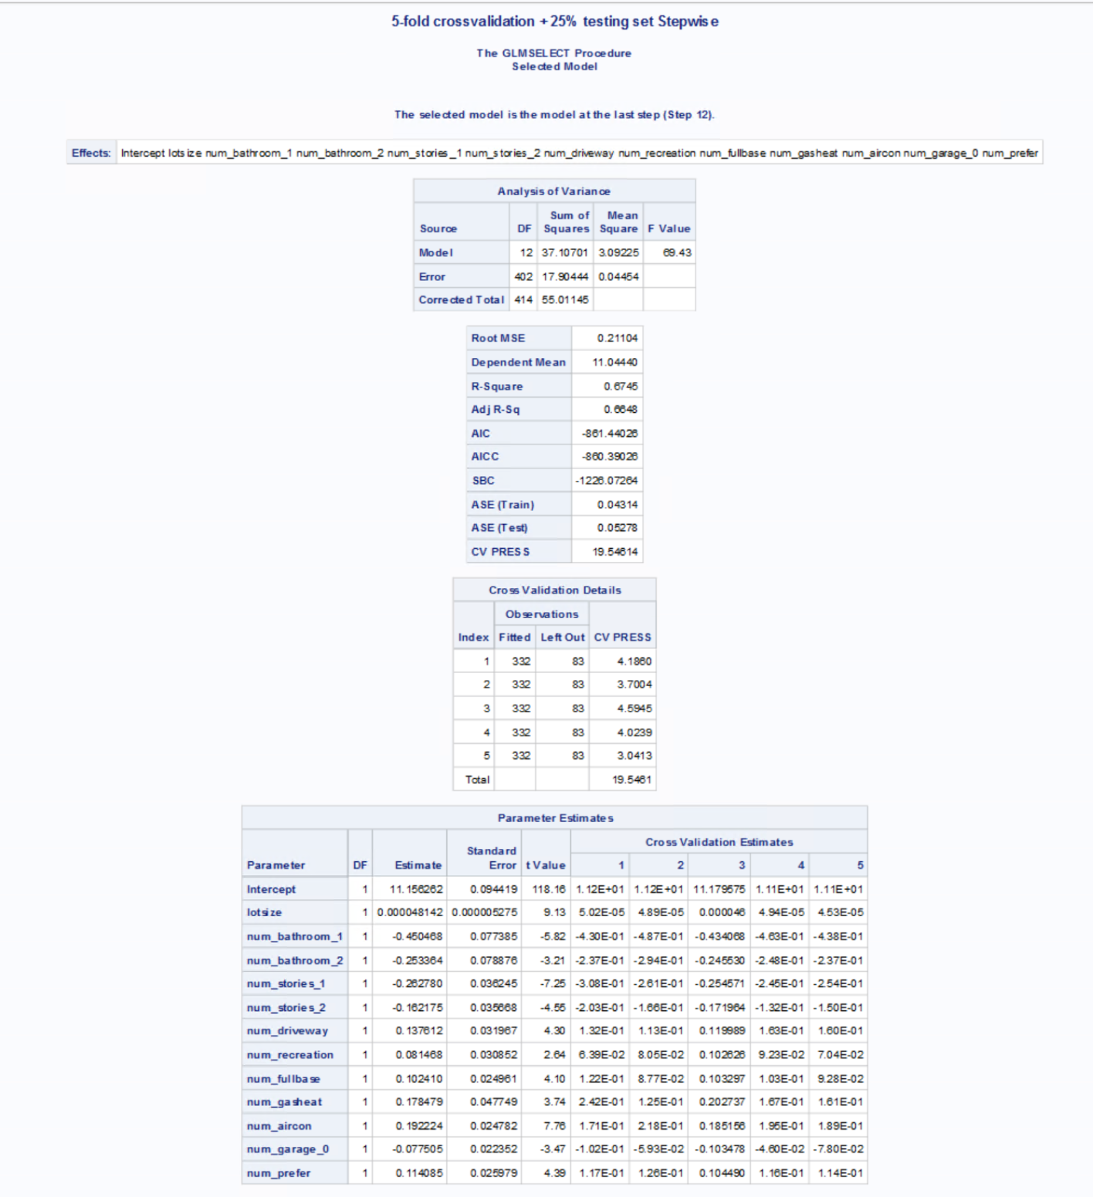**Appendix 26: 5- Fold Cross Validation + 25% testing using Stepwise**

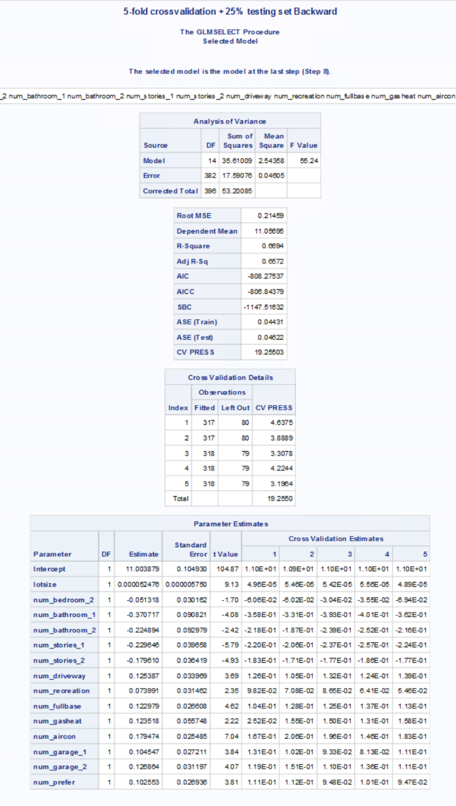**Appendix 27: 5- Fold Cross Validation + 25% testing using Backward**